Keeling Plot Protocol

Purpose: Keeling plots are used to measure the ¹³C of soil or ecosystem respiration in situ.

Note: Ideally, the air should be still while sampling. A slight breeze is OK, but if it is windy enough to change your ppm CO₂ (usually the wind causes it to drop or prevents it from rising), wait until the wind calms.

Supplies: Exetainers with new, unpierced septa
2 needles and needle connector tubing
Chamber and Collars
Licor with palm pilot or other data viewer attached
Gas tubing with quick connectors
Pump (inside a Tupperware with a switch, a battery, and gas tubing, which comes out through holes—this protects the pump from the elements)
Digital Watch

1. Collars will need to be installed in the ground. The collars are 10cm slices of large PVC tubing. To install them, cut into the soil with a knife using the collar like a stencil and push the collar into the soil. Some roots may have to be cut. It is recommended that you take your measurement immediately and then wait about two weeks before taking any other measurements so the decay of newly dead roots do not affect your results. Collars are left in the ground for as long as the sampling needs to occur.

2. Set up your Licor, pump, chamber, and tubing as illustrated (Figure 1). You want to make sure that the pump “out” is in line with the exetainer “in;” otherwise, the pump is not strong enough to push air through the needles in the extetainer.

3. Make sure your Licor has warmed up for half an hour.

4. With the Licor running and the pump attached, place the chamber over the collar carefully, avoiding breathing into the chamber as that would contaminate your sample. The chamber is on the collar properly when it creates a good seal such that the collar is attached to the chamber and could be lifted by pulling up on the chamber. A good way to tell if the chamber has been contaminated with breath is the Licor reading—it should be around 370-390 ppm. If it is greater than that, start over.

5. Start the pump with the needle connector tubing valve on, cutting off air flow from the needles. Turn on the data recorder on the palm pilot (or other device). It is useful to keep all the ppm versus time curves for each sample so if the data is weird, you can see why.

6. Open an exetainer to the outside air (avoid breathing). Label the exetainer. Attach the exetainer to the tubing by pushing the needles through the septa. Turn the needle connector tubing valve off and turn the needle valves on, allowing the air to flow into and out of the exetainer.

7. Record the time and the starting ppm in your field notebook.

8. After 2 minutes (enough time to make sure you are getting a well-homogenized air sample), turn the needle valves off and pull the exetainer off the needles carefully. Record the time and ending ppm in your notebook.

9. Repeat steps 6 through 8, at least 5 times in order to create a curve where ppm CO₂ changes with time. Therefore when you run the exetainer samples, the ¹³C will change as the ppm changes.

10. When finished taking samples, turn off the pump, stop recording the data, and move to the next collar.

11. Exetainers need to be run on the Gas Bench/IRMS in McCarty Hall within 7 to 10 days (the holding time tested in the literature). Contact Grace for info on running gas for ¹³C. If the exetainers need to be mailed by air, it is a good idea to mail some ¹³C standards with them to account for changes that might happen to the sample when they are subjected to low atmospheric pressures.

Protocol written by Caitlin Hicks, October 2008.

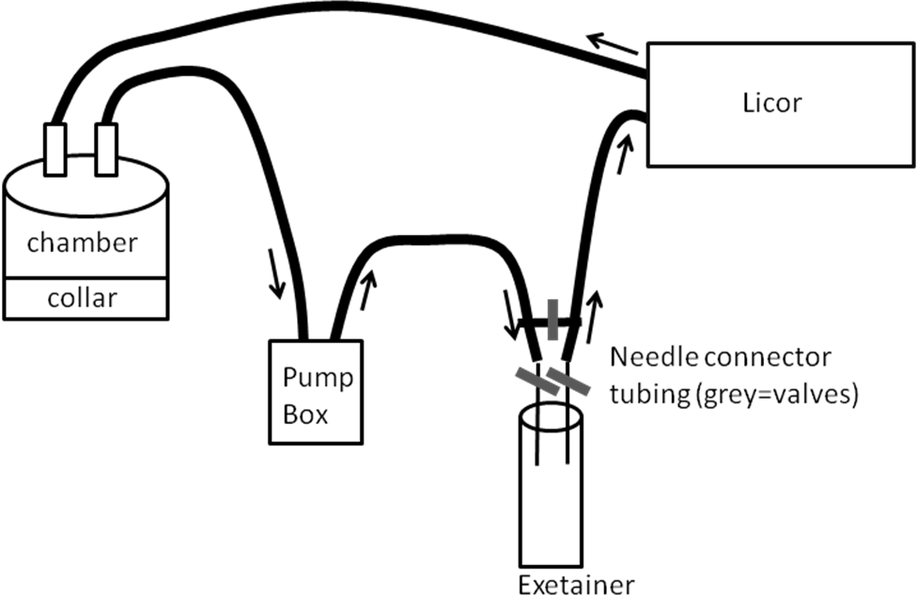
Figure 1. The set up for taking Keeling plot samples.

